Exercises 4 Discovering Object Interaction

Creating a Logical View use case diagram in rational rose

- Right-Click to select the logical view package in the browser and make the shortcut menu visible.
- Select the New: Use case Diagram menu choice. This will add a new use case diagram called NewDiagram to the browser.
- While the NewDiagram is still selected, enter the name Realizations

Creating Use Case Realizations in Rational Rose

- Double-click on the Realizations use case diagram in the browser to open the diagram
- Click to select the use case icon from the toolbar
- Click on the use case diagram window to place the use case, this will place the new use case on the diagram and also add it to the browser
- Double-click on the use case to open the use case specification
- Enter the name of the use case (same name as the use case in the use case view) in the Name field.
- Click the arrow in the stereotype field to make the drop-down menu visible
- Select use-case realization.
- Click the OK button to close the use case specification.

Creating a Sequence Diagram in Rational Rose

- Right-Click to select the use case realization in the Logical View of the browser and make the shortcut menu visible
- Select the New: Sequence Diagram menu choice. An unnamed sequence diagram is added to the browser.
- With the new sequence diagram selected, enter the name of the sequence diagram

Creating Objects and Messages in Sequence Diagram in Rational Rose

- Double-click on the sequence diagram in the browser to open the diagram
- Click to select the actor in the browser
- Drag the actor onto the sequence diagram
- Click on the sequence diagram window to place the object
- Click on the sequence diagram window to place the object
- While the object is still selected, enter the name of the object
- Repeat the proceeding steps for each object and actor in the scenario.
- Click to select the Object Message icon form the toolbar.
- Click on the actor or object sending the message and drag the message line to the actor or object receiving the message.
- While the message line is still selected, enter the name of the message.
- Repeat steps 7 through 9 for each message in the scenario

Assigning objects in a sequence diagram to classes in rational rose

- Click to select the class in the browser.
- Drag the class onto the object in the sequence diagram. Rose will add the class name preceded by a colon (:) to the object name. If the object is unnamed, the name is set to:className. If the stereotype display for a class is set to icon, and if an icon exists, then the icon will be used in the sequence diagram.

The solution as follows:
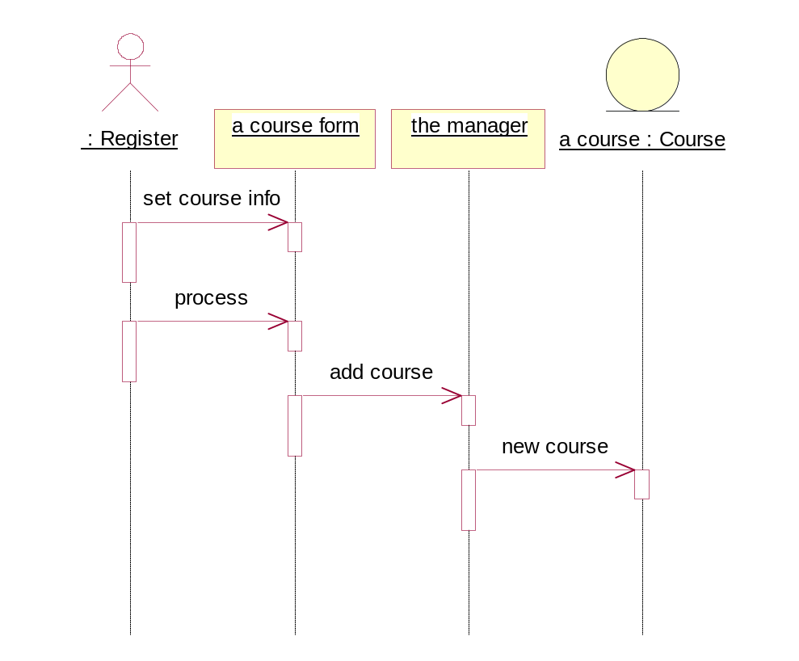
Creating Collaboration Diagram from Sequence Diagram in Rational Rose
- Double-click on the sequence diagram in the browser to open the diagram.
- Choose the browser: Create Collaboration Diagram menu choice or press the F5 Key
- Rearrange the objects and messages on the diagrams as needed.
The collaboration diagram is shown as follows:

